MTE Bugs/Changes Document #2

- There is no error message when uploading unsupported format file format.
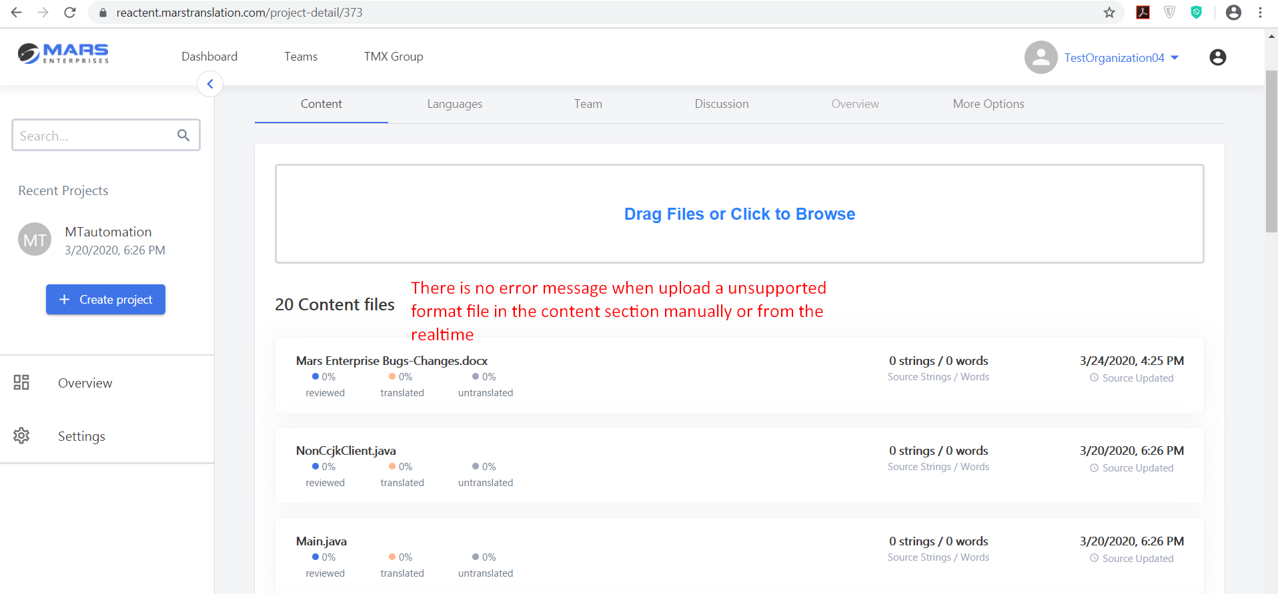
- Source and Target language cannot be same so please Add the Restrictions
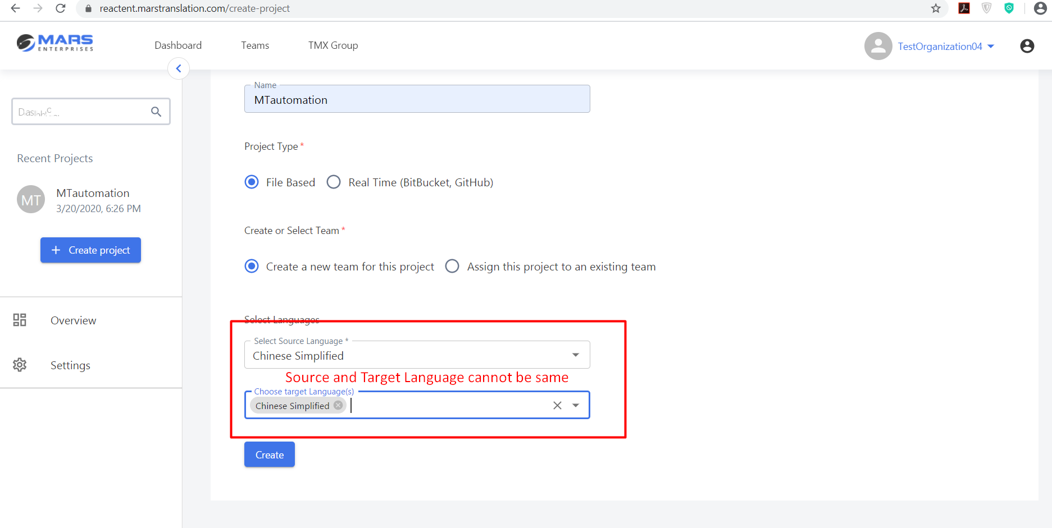

- Project name cannot be same even they have different Settings
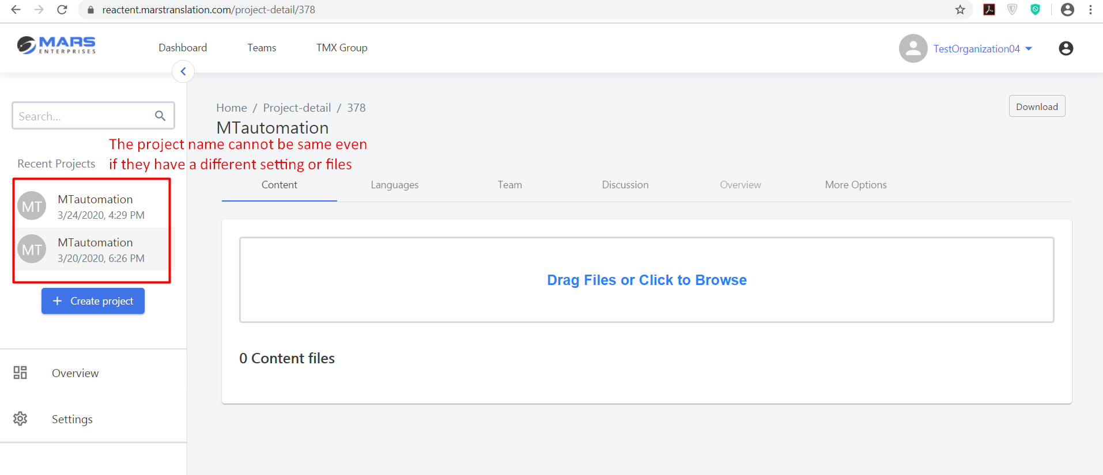
- Text color is not properly visible so there should be a bit Dark text
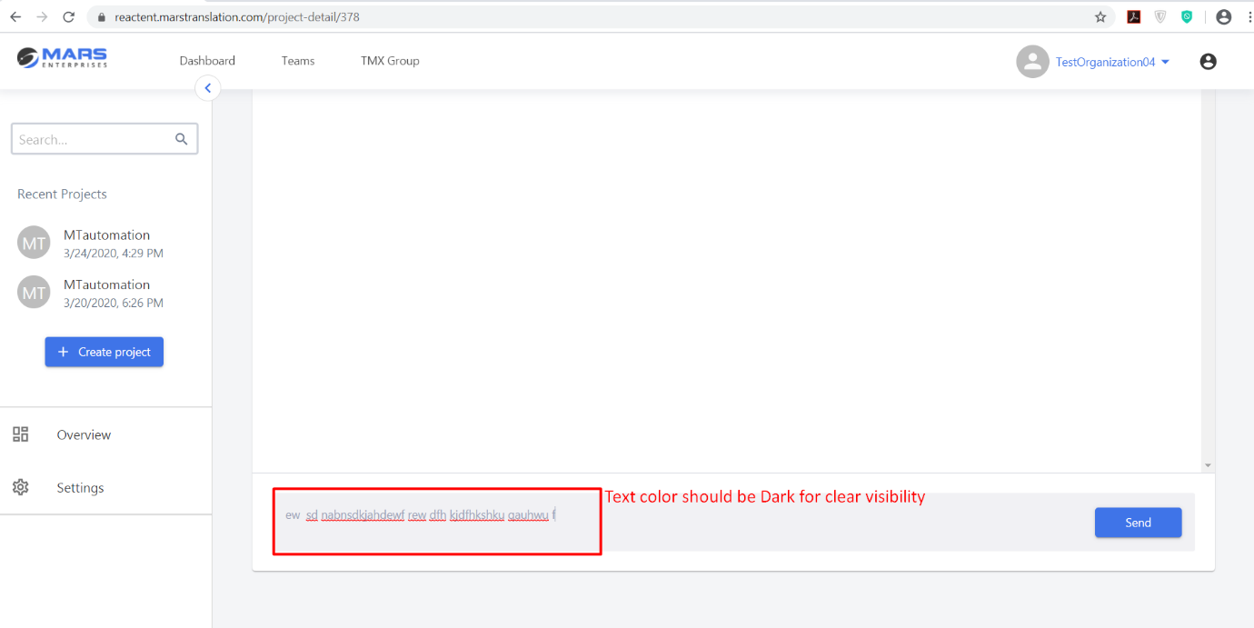
- Text and line are over riding
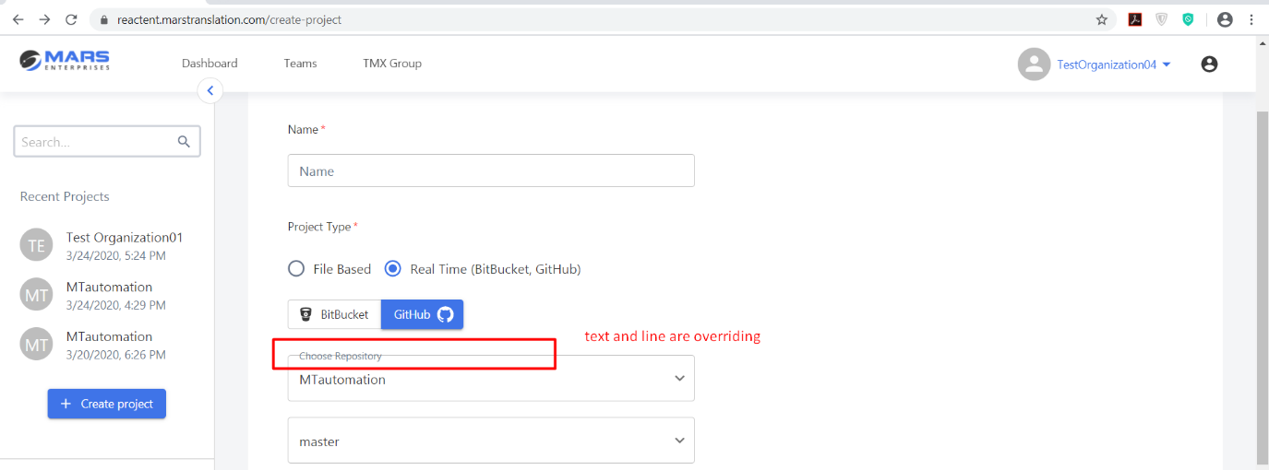
- System didn’t allow me to change the Realtime account.
